//2.find out the grade of school students

//-using switch control statement

#include <stdio.h>

int main(){

int marks;

printf("Enter your marks: ");

scanf("%d",&marks);

switch( marks / 10)

{

case 10:

case 9:

printf("You score A+");

break;

case 8:

printf("You score A");

break;

case 7:

printf("You score B+");

break;

case 6:

printf("You score B");

break;

case 5:

printf("You score C+");

break;

case 4:

printf("You score C");

break;

default:

printf("You are failed, study hard");

break;

}

}

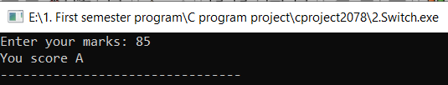

//3. Find odd and even number using function

#include <stdio.h>

void evenOdd(int num){

if(num%2==0){

printf("The number %d is even number ",num);

}else{

printf("The number %d is odd number ",num);

}

}

int main(){

int num;

printf("Enter a number: ");

scanf("%d",&num);

evenOdd(num);

return 0;

}

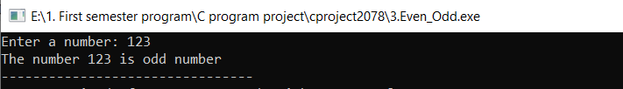

//4.sum of matrix 2x2

/\* Matrix addition \*/

#include<stdio.h>

int main()

{

int n=2;

int a[n][n],b[n][n],sum[n][n],i,j;

printf("\n Enter the size of Matrix 'A' ");

for(i=0;i<n;i++)

{

for(j=0;j<n;j++)

{

scanf("%d",&a[i][j]);

}

}

printf("\n Enter the size of matrix 'B' ");

for(i=0;i<n;i++)

{

for(j=0;j<n;j++)

{

scanf("%d",&b[i][j]);

}

}

for(i=0;i<n;i++)

{

for(j=0;j<n;j++)

{

sum[i][j]=a[i][j]+b[i][j];

}

}

printf("\n The sum of matrices A and B is ");

for(i=0;i<n;i++)

{

printf("\n");

for(j=0;j<n;j++)

{

printf("%d\t",sum[i][j]);

}

}

}

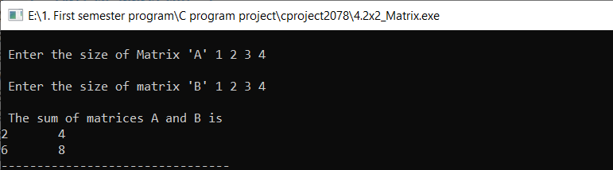

//5.Structure

#include <stdio.h>

struct Student{

char name[25],sex[10];

int age;

};

int main(){

int n=10,i;

Student s1[n];

for(i=0;i<n;i++){

printf("\nEnter the student %d information \n",i+1);

printf("Enter name: ");

scanf("%s",&s1[i].name);

printf("Enter age: ");

scanf("%d",&s1[i].age);

printf("Enter sex(Male or Female or Others): ");

scanf("%s",&s1[i].sex);

}

printf("\n\n\*\*\*\*\*\*\*\*Displaying the information of students\*\*\*\*\*\*\*\*\*");

for(i=0;i<n;i++){

printf("\n\nStudent %d information:\n",i+1);

printf("Name: %s ",s1[i].name);

printf("\nAge: %d ",s1[i].age);

printf("\nSex: %s ",s1[i].sex);

}

return 0;

}

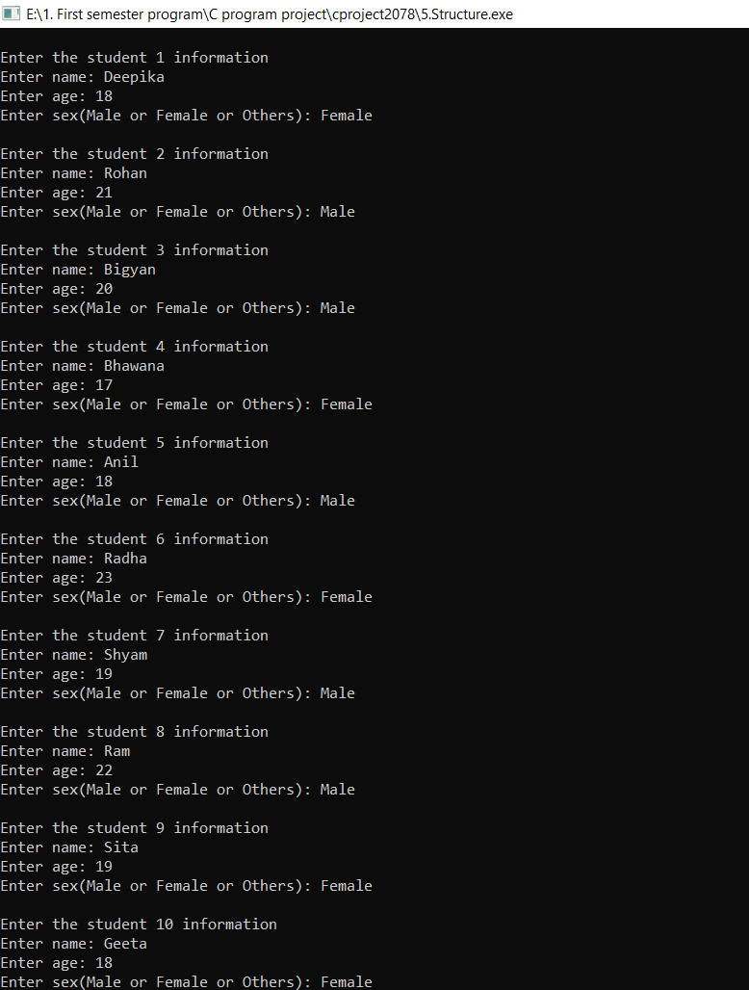

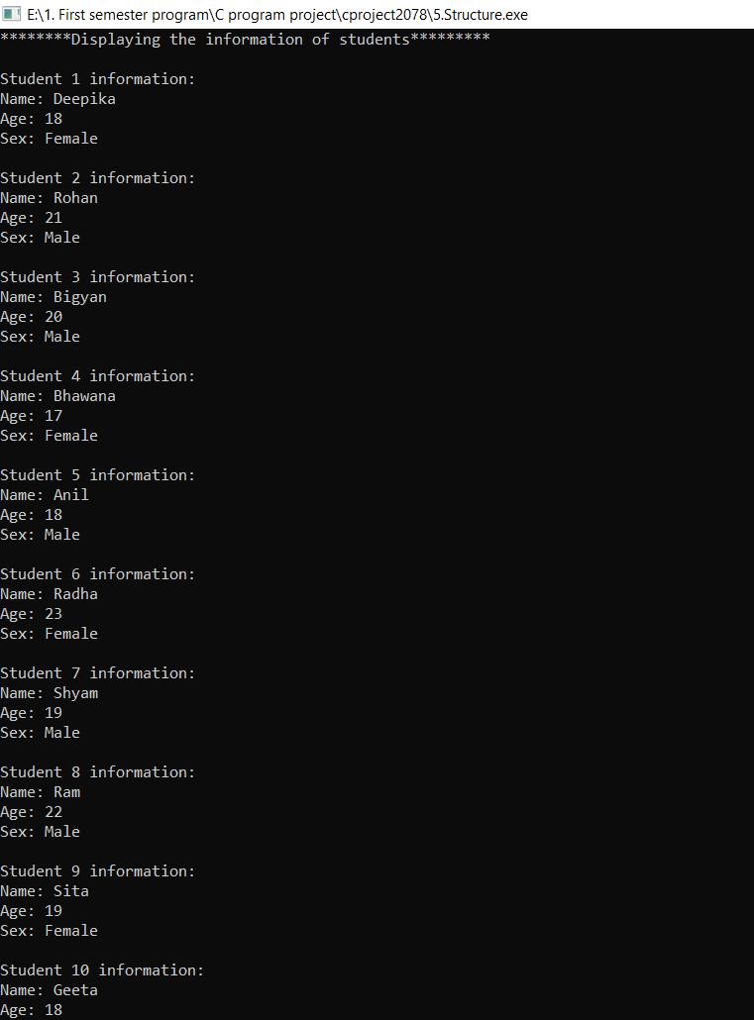

//6. add two number using pointer

#include <stdio.h>

int main(){

int a,b,sum,\*p1,\*p2;

printf("Enter two numbers: ");

scanf("%d%d",&a,&b);

p1=&a;

p2=&b;

sum=\*p1+\*p2;

printf("\n\nThe sum of %d and %d is %d ",a,b,sum);

return 0;

}

